**WorkSheet:- 3.1**

**Student Name:** Vivek Kumar **UID:** 21BCS8129

**Branch:** BE-CSE (LEET) **Section/Group:** 20BCS-809/A

**Semester:** 4th Sem **Date of Performance:** 20/04/2022

**Subject Name:** SE Lab **Subject Code:** 20CSP-255

**AIM: - Design a Gantt chart for a food delivery application.**

**Requirement Analysis:**

**Software Requirement**

* Windows10 / Mac-OS
* MS-Office or Excel

**Hardware requirement**

* + Computer / laptop
  + Power supply

**Solution: -** **Gantt chart** is a type of a bar chart that is used for illustrating project schedules. Gantt charts can be used in any projects that involve effort, resources, milestones and deliveries.

At present, Gantt charts have become the popular choice of project managers in every field.

Gantt charts allow project managers to track the progress of the entire project. Through Gantt charts, the project manager can keep a track of the individual tasks as well as of the overall project progression.

In addition to tracking the progression of the tasks, Gantt charts can also be used for tracking the utilization of the resources in the project. These resources can be human resources as well as materials used.

Gantt chart was invented by a mechanical engineer named Henry Gantt in 1910. Since the invention, Gantt chart has come a long way. By today, it takes different forms from simple paper-based charts to sophisticated software packages.

**The Use:**

As we have already discussed, Gantt charts are used for project management purposes. In order to use Gantt charts in a project, there are a few initial requirements fulfilled by the project.

First of all, the project should have a sufficiently detailed Work Breakdown Structure (WBS).

Secondly, the project should have identified its milestones and deliveries.

In some instances, project managers try to define the work break down structure while creating Gantt chart. This is one of the frequently practised errors in using Gantt charts. Gantt charts are not designed to assist WBS process; rather Gantt charts are for task progress tracking.

Gantt charts can be successfully used in projects of any scale. When using Gantt charts for large projects, there can be an increased complexity when tracking the tasks.

This problem of complexity can be successfully overcome by using computer software packages designed for offering Gantt chart functionalities.

**Gantt chart for a food delivery application:**

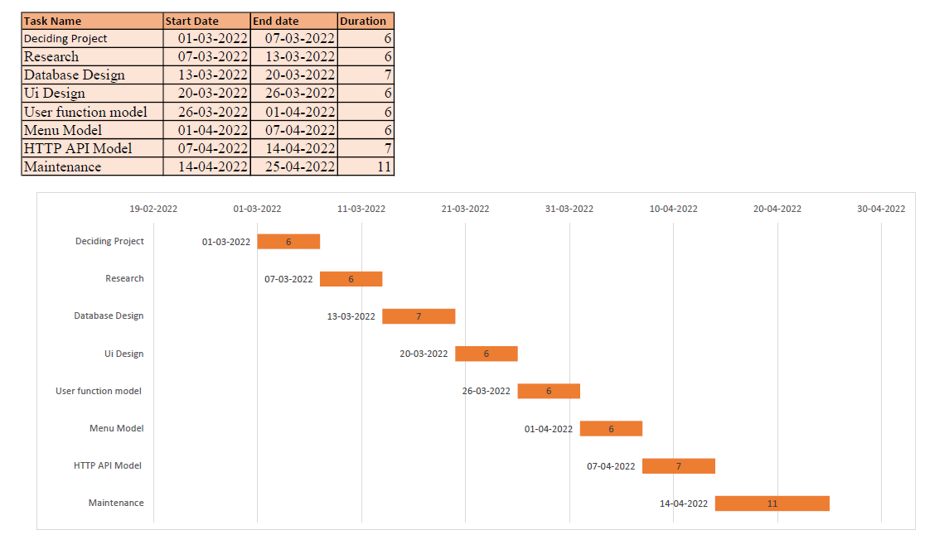

**Evaluation Grid (To be created as per the SOP and Assessment guidelines by the faculty):**

|  |  |  |  |
| --- | --- | --- | --- |
| Sr. No. | Parameters | Marks Obtained | Maximum Marks |
| 1. |  |  |  |
| 2. |  |  |  |
| 3. |  |  |  |
| 4. |  |  |  |